# 02 October 2014

## Overall layout

1. Sign up window – please add in Position Title

All these sections need to be compulsory

1. Currently the Home screen on the login is blank
2. Icons up the top currently do not work. Can we please change ‘my tasks’ to notifications – here we can let the client know if the patient has arrived or not to their appointment or if the appointment details of an existing appointment have been changed (here we will require an admin function, when admin alter the details of an existing appointment that a notification is sent through to the case managers login). Remove the spaceship icon and use the bell. Completed reports can be uploaded to the inbox.

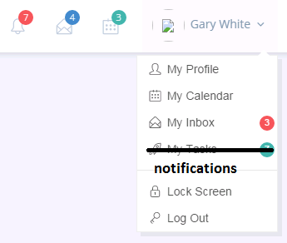

My calendar – will this show all up all the appointments that the client has booked?

1. What does my profile look like?
2. What does lock screen do?



1. What does this search screen, search?

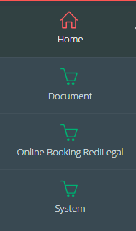

Can we please change these icons on the side, I don’t like the shopping carts. Makes me think we are online shopping, we would like to project a more professional feel.

## Document

I am assuming this is for the paperless set and will not be visible for clients?

## Online booking Redilegal: Booking

Location: the only locations we would like as an option are:

Belmont

Joondalup

Rockingham

Nedlands

Type: Please change the type to read - Independent Medical Examination not IME

Please see a list below clarifying the doctors and specialities and what types of appointments can be booked.

For Hanh’s availability can we make the following:

Belmont & Nedlands – only available for Plastic and reconstructive & Hand and finger injuries

Joondalup & Rockingham – available for all specialities

|  |  |  |  |
| --- | --- | --- | --- |
| Location | Type | Speciality | Doctor |
| Belmont  Joondalup  Nedlands  Rockingham | PI IME | Plastic and reconstructive  Hand and finger injuries | Dr Hanh Nguyen |
| Belmont | PI IME | Plastic and reconstructive  Hand and finger injuries | Dr Adrian Brooks |
| Belmont | PI IME | Plastic and reconstructive  Hand and finger injuries | Dr Daniel Luo |
| Belmont | PI IME | Hand and finger injuries  Lower Limb Orthopaedic  Upper Limb Orthopaedic | Dr Matthew Lawson-Smith |
| Belmont | PI IME | Lower Limb Orthopaedic  Upper Limb Orthopaedic  General Orthopaedic | Dr René Zellweger |
| Belmont | PI IME | Lower Limb Orthopaedic | Dr Matthew Scaddan |
| Belmont | PI IME | Lower Limb Orthopaedic  Upper Limb Orthopaedic | Dr Paul Khoo |
| Belmont | PI IME | Lower Limb Orthopaedic  Upper Limb Orthopaedic | Dr Toby Leys |

On the days where no appointments are available can we please include the following statement? Or something similar – we don’t want them to think we have nothing available.

For any specific requests please contact Redilegal on (08) 9230 0900 or [redilegal@redimed.com.au](mailto:redilegal@redimed.com.au)

Workers details – please change to – Patient Information

Birthday – please change to date of birth - please remove the calendar and just make the format as DD/MM/YYYY



Can we also include on this screen an option for the client to upload information. Please do not make this compulsory.

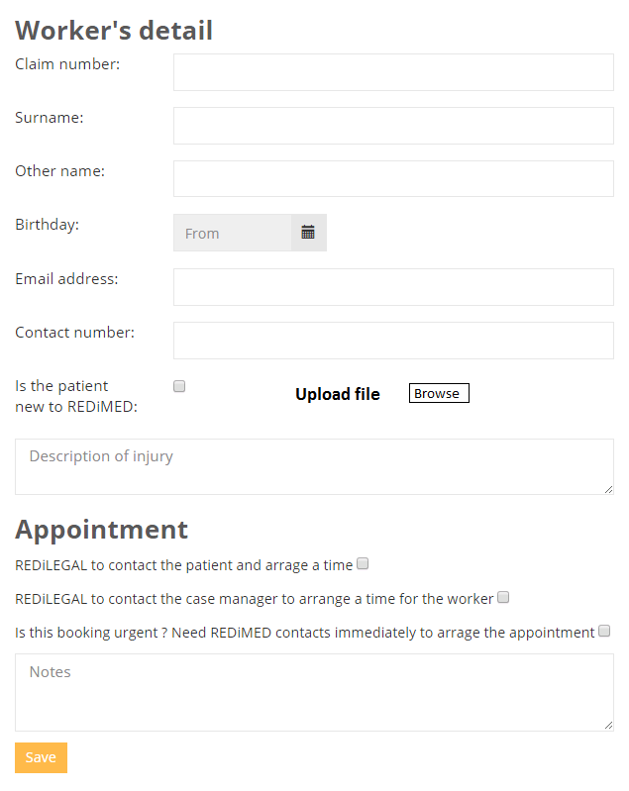

## Online booking Redilegal: Booking List

What do these boxes do? What is the purpose of the from..to.. boxes?

As a summary of the booking can we have:

Claim number – name (first and surname) – Type (can we have this abbreviated; PI, IME) – appointment date – remove booking date and replace with upload – so paperwork can be uploaded under the patient name from this screen 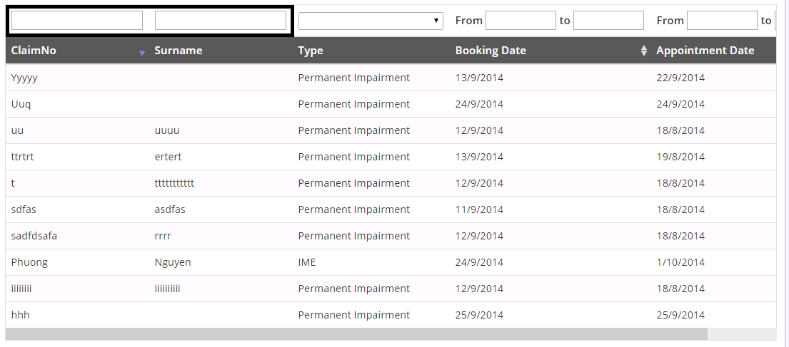

When you double click on the bar can we have a summary of the booking appear from the previous screen as below?

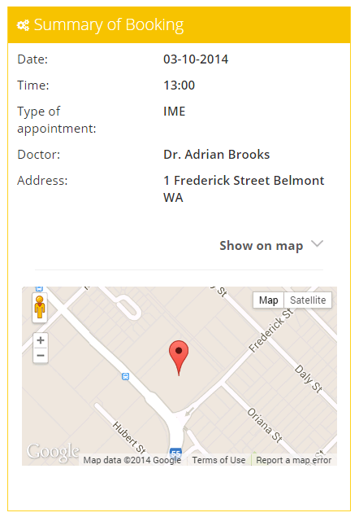

We will require the little arrows to sort through columns only for:

Type – appointment date